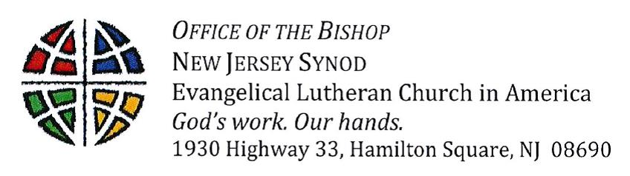

Dear Church,
During these days of high anxiety and fear around the COVID-19 pandemic, even though we are still in Lent, I have been carrying around with me the image of Jesus Christ entering the locked room where the disciples were hiding in fear following his resurrection. Jesus enters that room and speaks a word of peace into their fear. My prayer is you will know that peace today, and in the days ahead.
There is a lot we don’t know in regard to COVID-19 but we do know we will need to monitor the situation, follow recommendations by federal and local officials, and continue making decisions about our ministries for the next several weeks (and probably months). To that end, please note that the synod staff will continue working – some may come to the office as we have separate offices and can maintain appropriate physical distance from each other. Others are more comfortable working from home. Either way, you can reach us by phone and/or email. Scheduled meetings will be held electronically via Zoom (until at least the week after Easter). To reduce the number of people coming into the office, individual appointments will be kept as phone or video calls. Because this is an ever-changing situation, these decisions may need to be reconsidered – if that happens, you will be notified.
You should have received notice that our NJ Synod Assembly has been postponed until September 11-12, 2020. Further information can be found on our assembly webpage. We are still working out details of what that will mean for us and I ask for your patience as we do that.
Finally, I encourage you to consider how much time you spend on social media and listening to the news. Be aware of how an overload of information, judgement, and mis-information is affecting you and the people around you. Take time to go outside, read the Bible, and pray. I am suggesting that we all stop at noon each day and pray for each other*. By doing this, my hope is we will be reminded that we are bound together by a God who is more powerful than our fears, our anxieties, and COVID-19.
Your sister in Christ,
Bishop Tracie L. Bartholomew

*You could use this simple prayer based on a prayer for national distress from “A Prayer Book for the Armed Services”. Eternal God, amid all the turmoil and changes of the world your love is steadfast and your strength never fails. In this time of fear, danger, and trouble, be to us a sure guardian and rock of defense. Guide the leaders of our nation and nations around the world with your wisdom, comfort those in distress, and grant us courage and hope to face the future; through Jesus Christ, our Savior and Lord. Amen.

